# **Remote Desktop**

**Steps To Set Up PC For Remote Connections:**

1. Make sure you have Windows 10 Pro. To check this, go to Start > Settings > System > About and look for Edition.

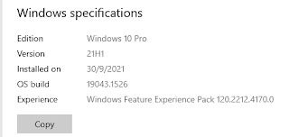

1. Go to Start > Settings > System > Remote Desktop. Turn on Enable Remote Desktop.

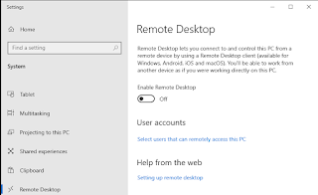

1. Click Confirm.

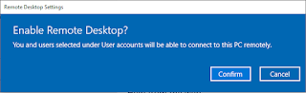

**Steps To Use Remote Desktop:**

1. In the search box on the taskbar, type Remote Desktop Connection, and then select Remote Desktop Connection.

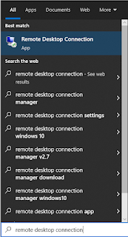

1. In Remote Desktop Connection, type the IP of the PC you want to connect to (from Steps To Set Up PC For Remote Connections), and then select Connect.

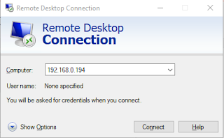

1. Enter credentials and click OK.

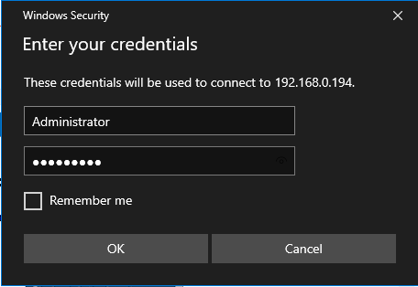

1. Done.

